**CSA0976 PROGRAMMING IN JAVA**

**NAME**: R. RITHVIK ROSHAN

**REG** **NO**: 192124021

**ASSIGNMENT 3**

1.CODE:

import java.awt.*;

import java.util.*;

import javax.swing.*;

public class ColorfulText extends JPanel implements Runnable {

private static final long serialVersionUID = 1L;

private int x, y;

private String message;

private Color color;

private Random random;

public ColorfulText() {

x = 50;

y = 50;

message = "Hello, world!";

color = Color.BLACK;

random = new Random();

}

@Override

protected void paintComponent(Graphics g) {

super.paintComponent(g);

g.setFont(new Font("Arial", Font.BOLD, 36));

g.setColor(color);

g.drawString(message, x, y);

}

@Override

public void run() {

while (true) {

try {

Thread.sleep(1000);

} catch (InterruptedException e) {

e.printStackTrace();

}

color = new Color(random.nextInt(256), random.nextInt(256), random.nextInt(256));

repaint();

}

}

public static void main(String[] args) {

JFrame frame = new JFrame("Colorful Text");

frame.setDefaultCloseOperation(JFrame.EXIT_ON_CLOSE);

frame.setSize(400, 200);

ColorfulText colorfulText = new ColorfulText();

frame.add(colorfulText);

frame.setVisible(true);

Thread thread = new Thread(colorfulText);

thread.start();

}

}

OUTPUT:

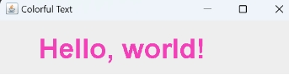

2.CODE:

class Table

{

void printTable(int n)

{

synchronized(this)

{

for(int i=1;i<=5;i++)

{

System.out.println(n+"*"+i+"="+(n*i));

try

{

Thread.sleep(500);

}

catch(Exception e)

{

System.out.println(e);

}

}

}

}

}

class Mythread1 extends Thread

{

Table t;

Mythread1(Table t)

{

this.t=t;

}

public void run()

{

t.printTable(5);

}

}

class Mythread2 extends Thread

{

Table t;

Mythread2(Table t)

{

this.t=t;

}

public void run()

{

t.printTable(10);

}

}

class Use

{

public static void main(String arg[])

{

Table obj=new Table();

Mythread1 th1=new Mythread1(obj);

Mythread2 th2=new Mythread2(obj);

th1.start();

th2.start();

}

}

OUTPUT:

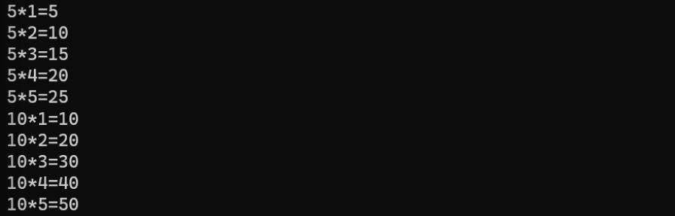

3.CODE:

import java.io.*;

import java.util.*;

class ugly

{

public static boolean ugl(int n)

{

if(n<=0)

{

return false;

}

while(n%2==0)

{

n/=2;

}

while(n%3==0)

{

n/=3;

}

while(n%5==0)

{

n/=5;

}

return n==1;

}

public static void main(String arg[])

{

int n;

Scanner a=new Scanner(System.in);

System.out.print("Enter a numnber :");

n=a.nextInt();

if(ugl(n))

{

System.out.print("True the given number is a ugly number");

}

else

{

System.out.print("False the given number is not a ugly number");

}

}

}

OUTPUT:

Enter a number :6

True the given number is a ugly number

Enter a number :14

False the given number is not a ugly number

4.CODE:

import java.io.*;

import java.util.*;

class fiboseries

{

public static void main(String arg[])

{

int n;

Scanner a=new Scanner(System.in);

System.out.print("Enter a number :");

n=a.nextInt();

if(n<0)

{

System.out.println("Enter a positive Integer ");

}

else

{

System.out.print("Output :"+fibonacci(n));

}

}

public static int fibonacci(int n)

{

if(n==1||n==0)

{

return(n);

}

else

{

return(fibonacci(n-1)+fibonacci(n-2));

}

}

}

OUTPUT:

Enter a number :1

Output :1

Enter a number :2

Output :1

Enter a number :3

Output :2

Enter a number :4

Output :3

5.CODE:

class duplicate

{

// Function to remove duplicate elements

// This function returns new size of modified

// array.

static int removeDuplicates(int arr[], int n)

{

// Return, if array is empty

// or contains a single element

if (n==0 || n==1)

return n;

int[] temp = new int[n];

// Start traversing elements

int j = 0;

for (int i=0; i<n-1; i++)

// If current element is not equal

// to next element then store that

// current element

if (arr[i] != arr[i+1])

temp[j++] = arr[i];

// Store the last element as whether

// it is unique or repeated, it hasn't

// stored previously

temp[j++] = arr[n-1];

// Modify original array

for (int i=0; i<j; i++)

arr[i] = temp[i];

return j;

}

public static void main (String[] args)

{

int arr[] = {10, 20, 20, 30, 40, 40, 40, 50, 50};

int n = arr.length;

n = removeDuplicates(arr, n);

// Print updated array

for (int i=0; i<n; i++)

System.out.print(arr[i]+" ");

}

}

OUTPUT:

10 20 30 40 50